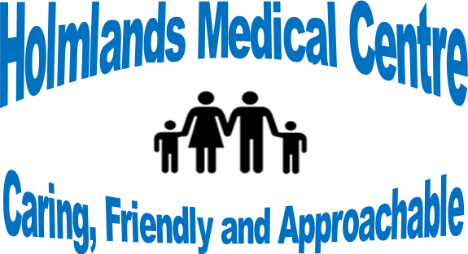

Microsoft Teams Meeting:
Holmlands Medical Centre Patient Participation Group meeting – 22.12.21
Present: Dr. P. Srivastava, Rachel Kavanagh, Paul Brady (in practice)
Virtual attendees: Ann Parry, Colin Derby, Jim Ainsworth (Chair), Dr. Bala Sridhar

Apologies: Jenny Pierce, Susan Davies

- Minutes from previous meeting
No further actions. RK updated members regarding non response from new member Colin Parry and leavers to the group, Janet Williams and Rebecca Major.

- Covid 19 Update – Vaccination Programme
Covid vaccination centre at Miriam Medical Centre is still delivering vaccinations on vast scale for Arno Network. As a practice we continue to contact patients due 1st 2nd and booster doses. Dr Srivastava explained that he had written to patients who had declined a Covid vaccination with a personal approach, and more educational reassurance for their decision making. It was agreed by members that the Miriam Medical Centre had done an excellent job with the vaccination programme and are continuing to do so. Dr. Mantgani who had received an award for his efforts, was congratulated by the staff at HMC.

- Building Plans/Grant
Since our last meeting there has been no progress made on the building improvements. However the group were kept up to date of instructions given to an architect to draw/design and plan for construction work. Dr. Bala Sridhar, offered to look at the 2021 submission to NHS England, and assist in representing the bid in 2022, to satisfy their queries in rejecting the earlier bid. The offer was gladly accepted.

- Patient/Staffing Information
Dr Srivastava informed the group that the patient list had increased to 3350, including a ‘refugee unsettled family’ joining the practice, organised by Wirral Borough Council. Dr PS also gave an update on staffing levels and new members of staff that have joined the team including Rachel Voller (ANP), Dr Sarkar (GP). Tracy Morgan (Nurse) had rejoined the practice, Frankey had left the office staff, but was replaced by Mia. In reply to a query from JA, RK stated that the practice web site provided a list of current staff.

- CQC Inspections.
Currently there is no requirement for a CQC inspection:
“We have not found evidence that we need to carry out an inspection or reassess our rating at this stage. This could change at any time if we receive new information. We will continue to monitor data about this service.”(CQC)
- AOB
Audits have been undertaken at the practice with input from Dr Srivastava and the Practice Pharmacist on:
    - Osteoporosis. Adding Calci-D 1000mg/1000iu chewable tablets to patients that fall into fracture risk groups and changing high-cost Calcium and Vitamin D supplements to Calci-D and high-cost Vitamin D to InVita-D3 800iu caps.
    - Looking into patients who have had suspected fragility.
    - Other audits so far this year, included COPD, Diabetes, Asthma, encouraging patient wellbeing, and cost savings.
- Date of next meeting: TBC.

